**Example #1**

**A+B.C**

|  |  |  |  |  |  |
| --- | --- | --- | --- | --- | --- |
| A | A | B | C | B.C | A+B.C |
| 1 | 0 | 1 | 1 | 1 | 1 |
| 1 | 0 | 1 | 0 | 0 | 0 |
| 1 | 0 | 0 | 1 | 0 | 0 |
| 1 | 0 | 0 | 0 | 0 | 0 |
| 0 | 1 | 1 | 1 | 1 | 1 |
| 0 | 1 | 1 | 0 | 0 | 1 |
| 0 | 1 | 0 | 1 | 0 | 1 |
| 0 | 1 | 0 | 0 | 0 | 1 |

|  |  |  |
| --- | --- | --- |
| **A** | **B** | **A.B** |
| **1** | **1** | **1** |
| **1** | **0** | **1** |
| **0** | **1** | **1** |
| **0** | **0** | **0** |

**Task # 1:** Verify the operation of NOT, AND, OR, NAND and NOR Gates using MultiSim and attach the circuit snapshots?**AND (A.B)**

**OR (A+B)**

**NOT (!A)**

**NAND (A.B)**

**NOR (A+B)**

**Task # 1:** Implement the following equations on MultiSim and verify through Truth Table. (Attach the circuit snapshots)

* (A+ B + C). (A + C+ D).(B+ C + D)

|  |  |  |  |  |  |  |  |  |  |  |  |
| --- | --- | --- | --- | --- | --- | --- | --- | --- | --- | --- | --- |
| **s** | **B** | **C** | **D** | **A** | **B** | **C** | **D** | **A+B+C** | **A+C+D** | **B+C+D** | **(A+B+C).(A+C+D).(B+C+D)** |
| **1** | **1** | **1** | **1** | **0** | **0** | **0** | **0** | **1** | **1** | **1** | **1** |
| **1** | **1** | **1** | **0** | **0** | **0** | **0** | **1** | **1** | **0** | **1** | **0** |
| **1** | **1** | **0** | **1** | **0** | **0** | **1** | **0** | **1** | **1** | **1** | **1** |
| **1** | **1** | **0** | **0** | **0** | **0** | **1** | **1** | **1** | **1** | **1** | **1** |
| **1** | **0** | **1** | **1** | **0** | **1** | **0** | **0** | **1** | **1** | **1** | **1** |
| **1** | **0** | **1** | **0** | **0** | **1** | **0** | **1** | **1** | **0** | **1** | **0** |
| **1** | **0** | **0** | **1** | **0** | **1** | **1** | **0** | **1** | **1** | **0** | **0** |
| **1** | **0** | **0** | **0** | **0** | **1** | **1** | **1** | **1** | **1** | **1** | **1** |
| **0** | **1** | **1** | **1** | **1** | **0** | **0** | **0** | **1** | **1** | **1** | **1** |
| **0** | **1** | **1** | **0** | **1** | **0** | **0** | **1** | **1** | **1** | **1** | **1** |
| **0** | **1** | **0** | **1** | **1** | **0** | **1** | **0** | **0** | **1** | **1** | **0** |
| **0** | **1** | **0** | **0** | **1** | **0** | **1** | **1** | **0** | **1** | **1** | **0** |
| **0** | **0** | **1** | **1** | **1** | **1** | **0** | **0** | **1** | **1** | **1** | **1** |
| **0** | **0** | **1** | **0** | **1** | **1** | **0** | **1** | **1** | **1** | **1** | **1** |
| **0** | **0** | **0** | **1** | **1** | **1** | **1** | **0** | **1** | **1** | **0** | **0** |
| **0** | **0** | **0** | **0** | **1** | **1** | **1** | **1** | **1** | **1** | **1** | **1** |

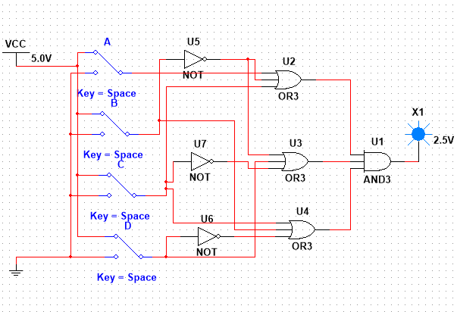

* ABCD + A (B +C) + BCD + ABD+ BC

|  |  |  |  |  |  |  |  |  |  |  |  |  |
| --- | --- | --- | --- | --- | --- | --- | --- | --- | --- | --- | --- | --- |
| **A** | **B** | **C** | **D** | **B** | **C** | **D** | **ABCD** | **A(B+C)** | **BCD** | **ABD** | **BC** | ABCD+A(B+C)+BCD+ABD+BC |
| **1** | **1** | **1** | **1** | **0** | **0** | **0** | **0** | **1** | **0** | **1** | **0** | **1** |
| **1** | **1** | **1** | **0** | **0** | **0** | **1** | **0** | **1** | **1** | **0** | **0** | **1** |
| **1** | **1** | **0** | **1** | **0** | **1** | **0** | **0** | **1** | **0** | **1** | **1** | **1** |
| **1** | **1** | **0** | **0** | **0** | **1** | **1** | **0** | **1** | **0** | **0** | **1** | **1** |
| **1** | **0** | **1** | **1** | **1** | **0** | **0** | **1** | **1** | **0** | **0** | **0** | **1** |
| **1** | **0** | **1** | **0** | **1** | **0** | **1** | **0** | **1** | **0** | **0** | **0** | **1** |
| **1** | **0** | **0** | **1** | **1** | **1** | **0** | **0** | **0** | **0** | **0** | **0** | **0** |
| **1** | **0** | **0** | **0** | **1** | **1** | **1** | **0** | **0** | **0** | **0** | **0** | **0** |
| **0** | **1** | **1** | **1** | **0** | **0** | **0** | **0** | **0** | **0** | **0** | **0** | **0** |
| **0** | **1** | **1** | **0** | **0** | **0** | **1** | **0** | **0** | **1** | **0** | **0** | **1** |
| **0** | **1** | **0** | **1** | **0** | **1** | **0** | **0** | **0** | **0** | **0** | **1** | **1** |
| **0** | **1** | **0** | **0** | **0** | **1** | **1** | **0** | **0** | **0** | **0** | **1** | **1** |
| **0** | **0** | **1** | **1** | **1** | **0** | **0** | **0** | **0** | **0** | **0** | **0** | **0** |
| **0** | **0** | **1** | **0** | **1** | **0** | **1** | **0** | **0** | **0** | **0** | **0** | **0** |
| **0** | **0** | **0** | **1** | **1** | **1** | **0** | **0** | **0** | **0** | **0** | **0** | **0** |
| **0** | **0** | **0** | **0** | **1** | **1** | **1** | **0** | **0** | **0** | **0** | **0** | **0** |

